CE2107 Lab2 Assignment Sheet (to be submitted to NTULearn before next lab)

Name: Dayna Chia Lab Group: SE1 Date: 15/09/22

1. Section 6.2. Give a short 2-3 lines description on concept behind the reflectance reading process. Why does the black surface result in slower voltage decay?

A black surface has lower reflectance as compared to a white surface, so it does not reflect as much IR wave back to the base of the transistor. Less current flows through the collector-emitter and the capacitor is discharged at a slower rate, resulting in a slower voltage decay. After the time delay, capacitor voltage would not have decayed to zero and would still be at a logic high.

1. Section 6.2. Which parameter do you need to tweak in the Reflectance_Read() if the reflectance sensor reading is not accurate? Hint: check the 8 steps for Reflectance reading.

The ‘time’ parameter in Step 5.

1. Section 6.2. Write down the procedure to initialise P7.4 to be an input pin without internal pull-up resistor

P7->SEL0 = 0x00;

P7->SEL1 = 0x00;

P7->DIR = 0x00;

P7->REN = 0x00;

1. Section 6.3. Where are the sources of the offset error between actual distance and the estimated distance return by the function Reflectance_Position()?

Spacing between the sensors. For example, the robot may be slightly off centre but because sensors 4 and 5 are above the black line, 0001 1000 is read and estimated distance returned by the function will still be 0.

1. Section 7.2.  Figure 7. The robot state toggled between LEFT and CENTER state repeatedly when it is detected that the robot is off to the left of the line (input: ‘01’). Under such condition, do you expect the robot to move toward the right in the zig-zag pattern or do you expect it to move in the smooth curve. Assume we shorten the time in each state from 500msec to 5 msec.

Zig-zag

1. Section 7.3. Fix the bug in the 11-state FSM design.  
   A picture containing table

   Description automatically generated

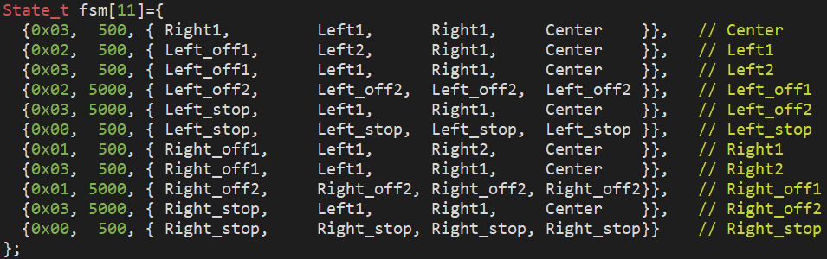

1. Section 7.3. What is the purpose of toggling LED within the main routine or ISR?

Toggling the LED allows for checking of the robot’s response to the lines’ position below it, as the different LED colors correspond to the different simulated motor movements.

1. Section 7.4. What hardware and software modifications are required in order for the robot to move within a lane, i.e. between two black lines, instead of following a line? Detail algorithm not required. Just one bullet point each for hardware and software.

* Hardware: Two separate sensor arrays to be positioned above the two lines
* Software: FSM states to take into account the center 2 bits for both sensor arrays